Daimonji Sushi Restaurant

# Purpose and Objectives

The purpose of this website is to provide customers with an overview of Daimonji Sushi Restaurant, showcasing some of the menu items, including appetizers, main courses, drinks, and desserts.

# Frontend Design

Domain Name: [www.daimonjisushiseattle.com](http://www.daimonjisushiseattle.com) (not yet acquired)

## Audience and flow:

Currently, Daimonji Sushi does not have a functional website. The restaurant has been operating for 10 years and currently uses physical menus. Online, it can only be found via a Yelp page and Google reviews.

Customers will be able to visit the website to explore the menu, including appetizers, main courses, drinks, and desserts. Users will also be able to find the website through search engines. When dining at the restaurant, customers can scan a QR code displayed at the table to access the site on their phones.

## Sketch and Page Layout

The website layout is being developed in **Figma**, showcasing both the desktop/PC version and the mobile view for smartphone users. [Sushi Restaurant – Figma](https://www.figma.com/design/vsmRnNMIIx4EFmOy3eaNRW/Sushi-Restaurant?node-id=0-1&node-type=canvas&t=lSJ32B8yFc1rK4dj-0)

# User stories

1. As a user, I want to view the latest menu items from Daimonji Sushi on my phone or computer.
2. As a user, I want to filter menu items by whether they are cooked or raw (stretch goal).
3. As a user, I want to filter sashimi items by fish type (stretch goal).
4. As an admin, I want to view the current inventory of products and supplies.

# Front End Color Scheme

The main page will use contrasting colors:

* **#FCFAEE** (floralwhite)
* **#B8001F** (firebrick)

Some components, such as the header and footer, will be styled using **Material UI**.

Example of desktop version of the site: [Sushi Restaurant – Figma](https://www.figma.com/design/vsmRnNMIIx4EFmOy3eaNRW/Sushi-Restaurant?node-id=0-1&node-type=canvas&t=UEF46CO6LqnoyiT4-0)

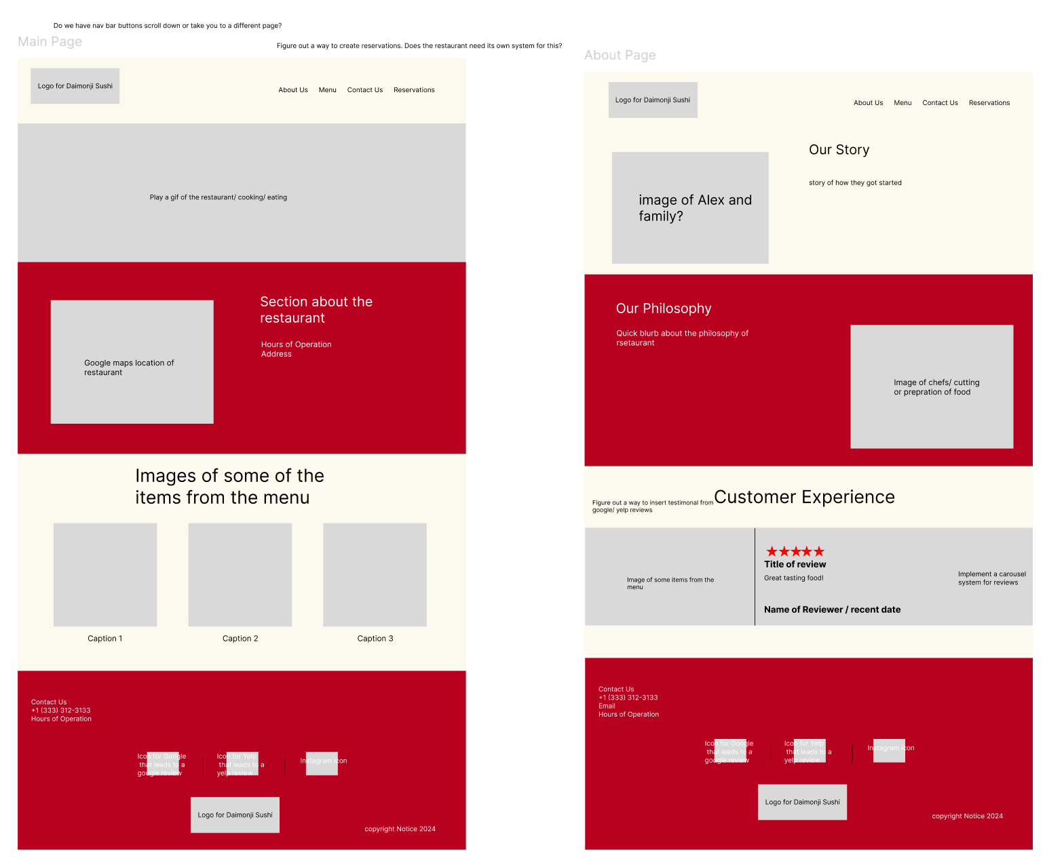

# Accessibility Features

To ensure accessibility for all users, the website will include the following features (based on the [Website Accessibility Checklist (15 Best Practices) | Website Setup](https://websitesetup.org/web-accessibility-checklist/))

1. Appropriate color contrast
2. A “light mode” and “dark mode” toggle
3. Alternative text for images
4. Responsive design with larger buttons and clearly visible links
5. Focus CSS properties for buttons and labels to improve visual indicators

# Mobility Features

The application will be **web-based only**, with no Android or iOS versions planned. However, responsive design will ensure that the web app is easily viewable and functional on handheld devices. Example of responsive design: [Sushi Restaurant – Figma](https://www.figma.com/design/vsmRnNMIIx4EFmOy3eaNRW/Sushi-Restaurant?node-id=13-212&node-type=canvas&t=htVBoHkXm0cOSfie-0)

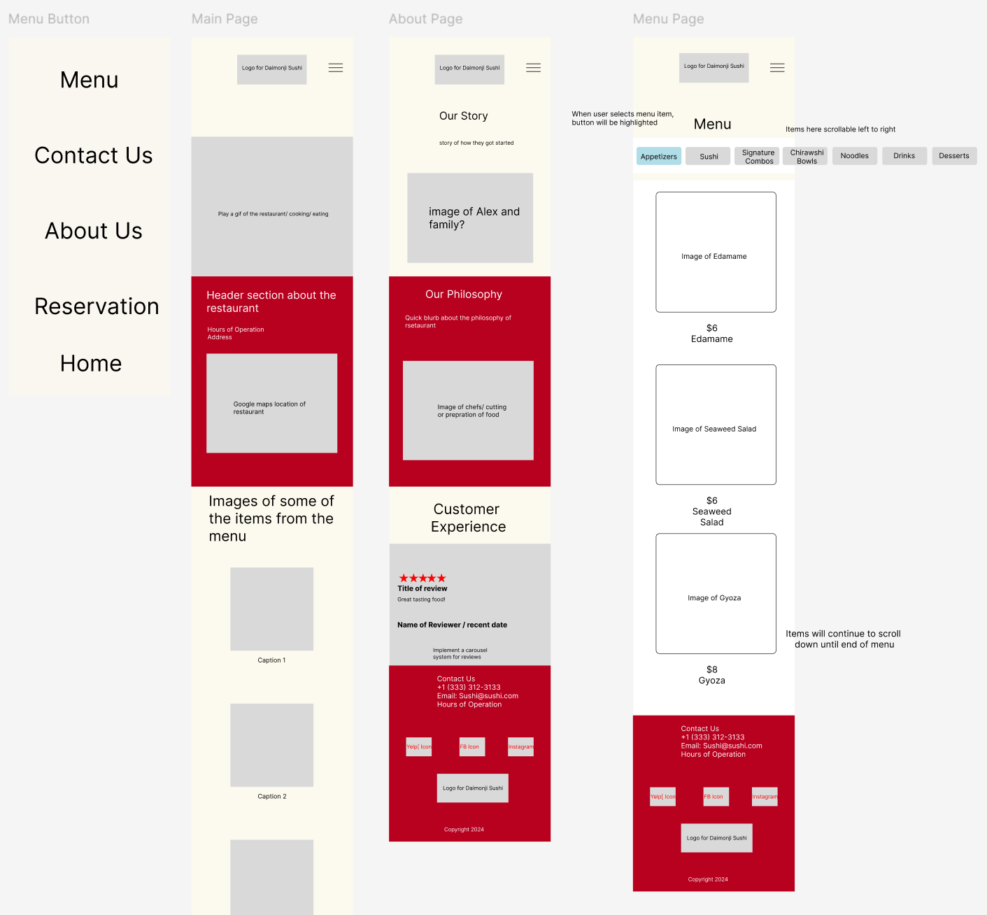

# Backend

The backend system will use **PostgreSQL** to manage the database and maintain inventory tracking. It will allow the restaurant to monitor ingredient availability and determine if certain menu items can be offered or should be marked unavailable.

Both the frontend and backend will leverage **Next.js**. The framework will support the implementation of a simple REST API to track ingredients and menu availability.

Example of file structure:

# Security Features

In addition to the security provided by the hosting platform, the website will incorporate the following best practices: ([An Overview of Best Practices for Security Headers | Okta Developer](https://developer.okta.com/blog/2021/10/18/security-headers-best-practices#x-xss-protection))

1. **Security Headers** – To protect the site from vulnerabilities. Examples include:
   1. **Content Security Policy (CSP):** Controls what resources the browser can load.
   2. **Permissions-Policy:** Limits unnecessary features to enhance security.
2. **Error Handling:** Ensures that sensitive information is not displayed to users if an error occurs.

# Hosting

I am currently hosting the frontend of the website on Vercel, leveraging Next.js for seamless deployment and ease of concurrent development. For the backend, I aim to use a cost-effective solution that ensures reliable hosting. Render stands out as a viable option, offering a $0 hobby plan that conveniently supports integration between the frontend and backend.